**Activity #3: Building a Personal Portfolio Page Using Bootstrap**

**Objective:** Create a personal portfolio page using Bootstrap components, including Carousel, Grid, Table, and Card. This activity will help you understand how to integrate different Bootstrap elements to build a cohesive and visually appealing webpage.

**Instructions:**

1. **Setup Bootstrap:**
   * Include the Bootstrap CDN in your HTML file by adding the following lines within the <head> section:

*<link href=<https://stackpath.bootstrapcdn.com/bootstrap/4.5.2/css/bootstrap.min.css> rel="stylesheet">*

*<script src="https://code.jquery.com/jquery-3.5.1.slim.min.js"></script>*

*<script src="https://cdn.jsdelivr.net/npm/@popperjs/core@2.5.4/dist/umd/popper.min.js"></script>*

*<script src="https://stackpath.bootstrapcdn.com/bootstrap/4.5.2/js/bootstrap.min.js"></script>*

1. **Create a Navigation Bar:**
   * Use Bootstrap to create a responsive navigation bar at the top of your portfolio page.
   * Include links to different sections of your page, such as "Home," "About," "Projects," "Skills," and "Contact."
2. **Add a Carousel:**
   * Create a Carousel component to showcase your top 3 projects or achievements with images and captions.
   * Ensure the Carousel is responsive and includes controls for navigation.
3. **Grid Layout for Skills:**
   * Use a Grid layout to list your skills.
   * Each skill should be placed in a separate Card component.
   * Arrange the Cards in a responsive grid that looks good on various screen sizes.
4. **Table for Education and Work Experience:**
   * Create a Table to display your education and work experience.
   * The table should include columns for the institution/company, degree/position, and years attended/employed.
   * Use Bootstrap classes to style the table for a clean and professional look.
5. **Cards for Portfolio Projects:**
   * Add Cards to present detailed information about at least three portfolio projects.
   * Each Card should include a title, description, and links to the project or GitHub repository.
   * Use Bootstrap classes to ensure the Cards are responsive and visually appealing.
6. **Finalize and Style:**
   * Add additional styles as needed to personalize your portfolio.
   * Ensure the page is responsive and looks good on different devices.
   * Consider using custom CSS for additional styling beyond what Bootstrap offers.
7. **Test and Refine:**
   * Open your HTML file in various web browsers and devices to ensure it is fully responsive and functional.
   * Make adjustments as needed to improve the layout and appearance.
8. **Save and Submit:**
   * Save your HTML file and any related assets (e.g., images, CSS files).
   * Submit the file on Canvas.

**Tips:**

* Refer to the Bootstrap documentation for additional guidance and examples.
* Use high-quality images for the Carousel and project Cards to enhance the visual appeal.
* Keep the design clean and professional, ensuring that the content is easy to read and navigate.

**PAGES/SECTIONS OF THE WEBSITE**

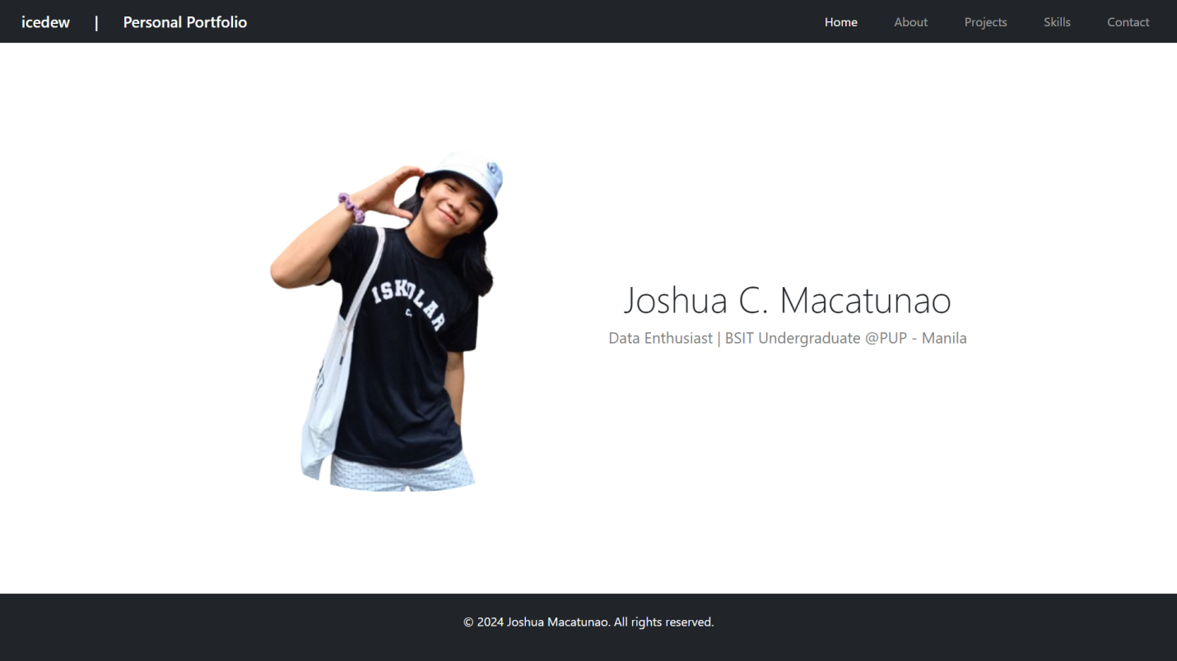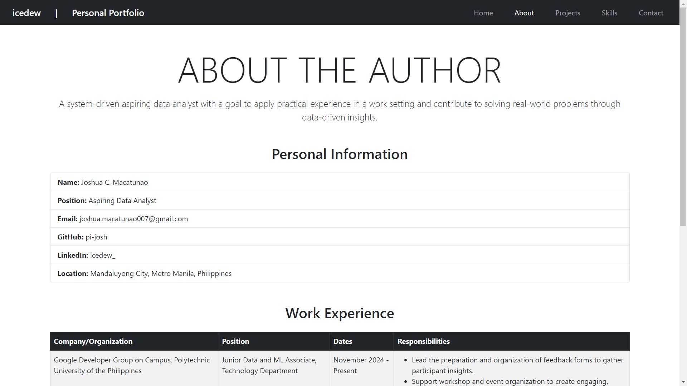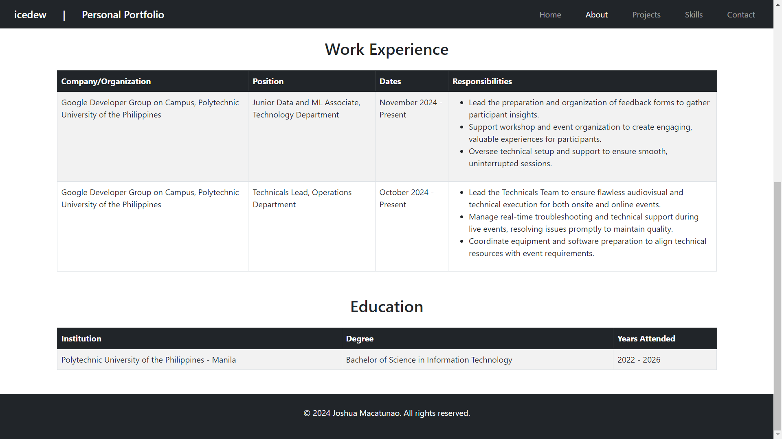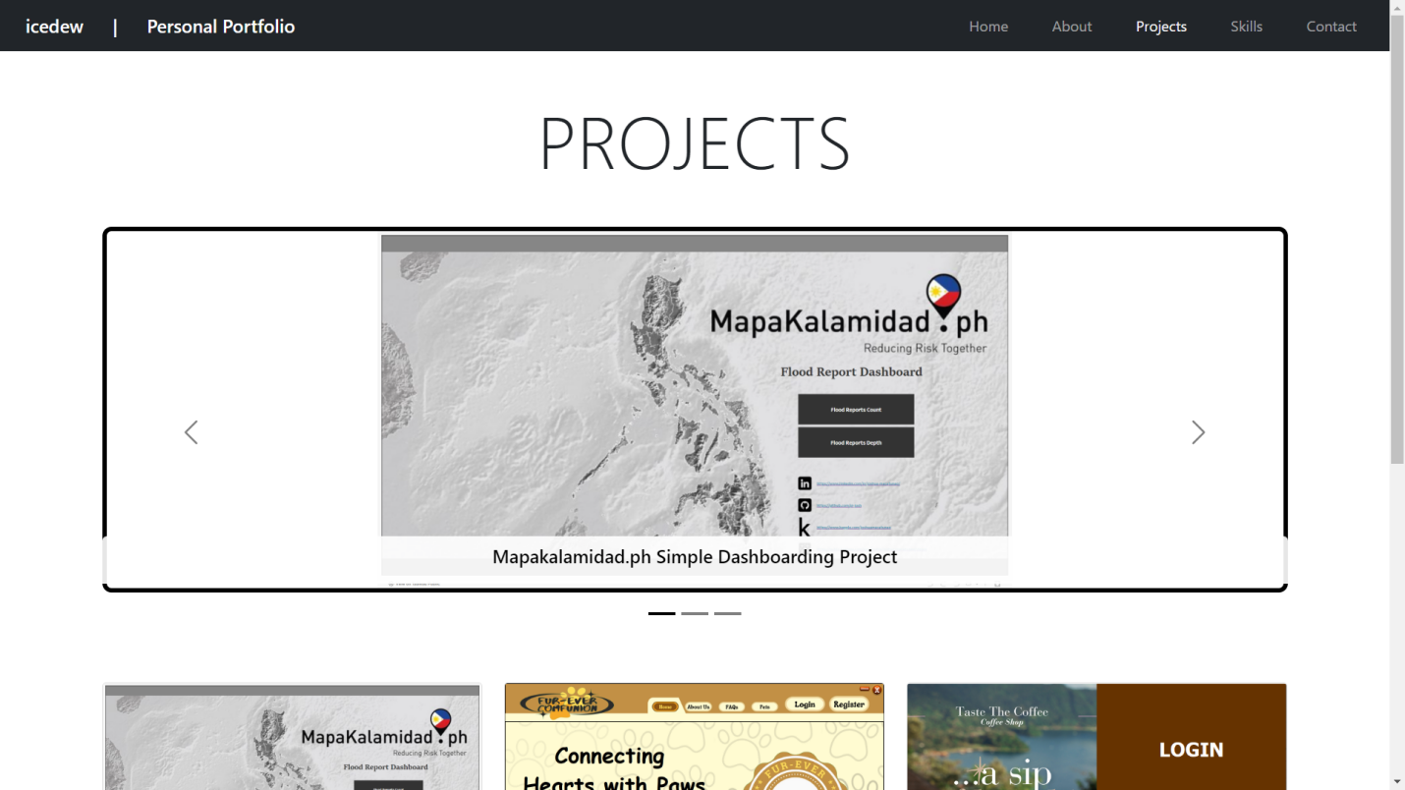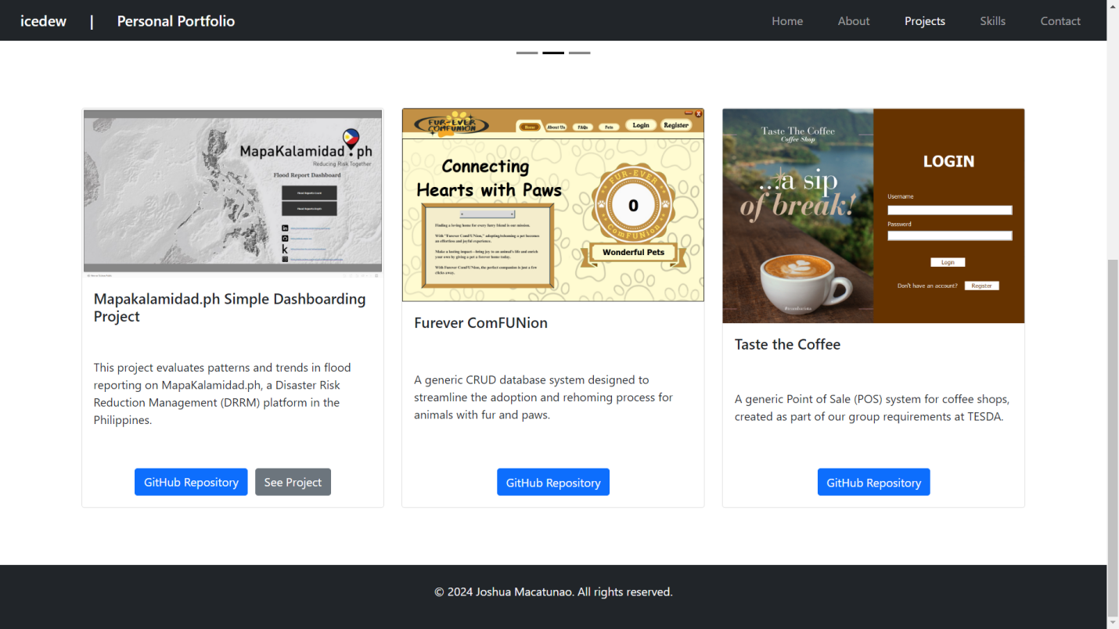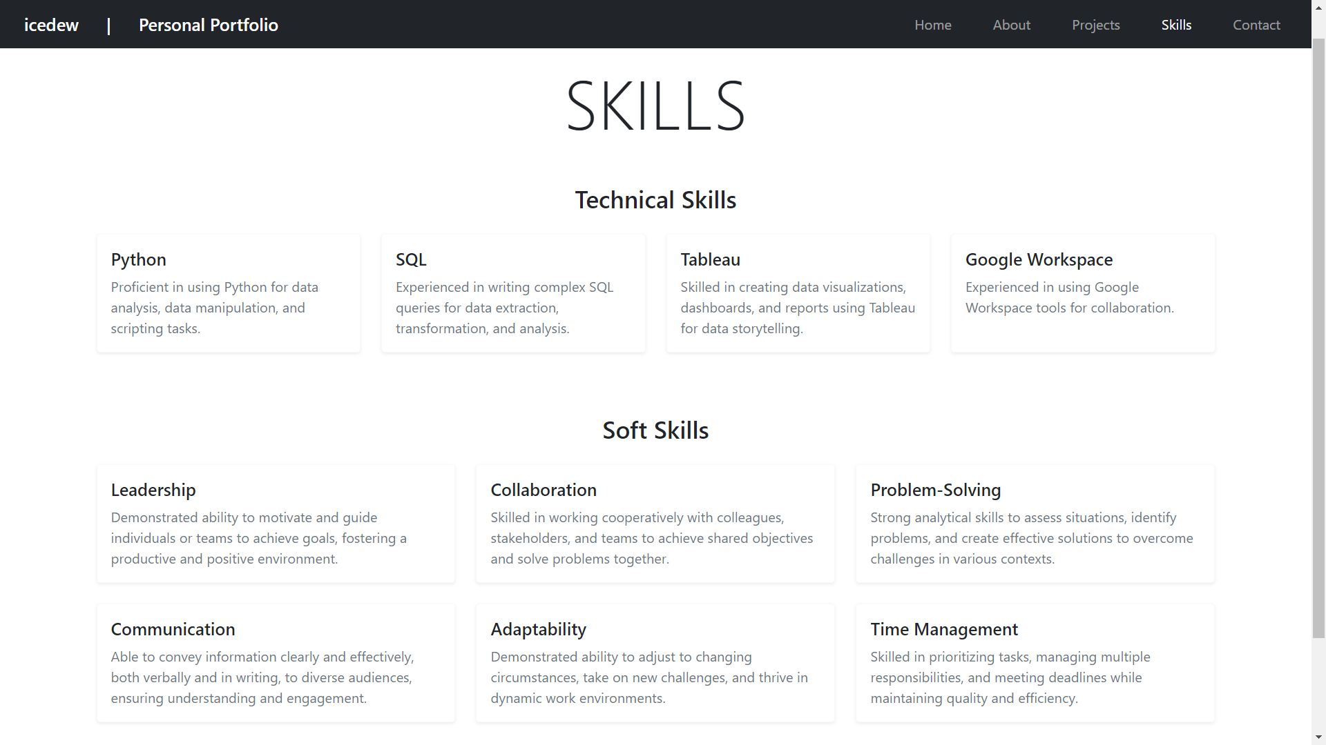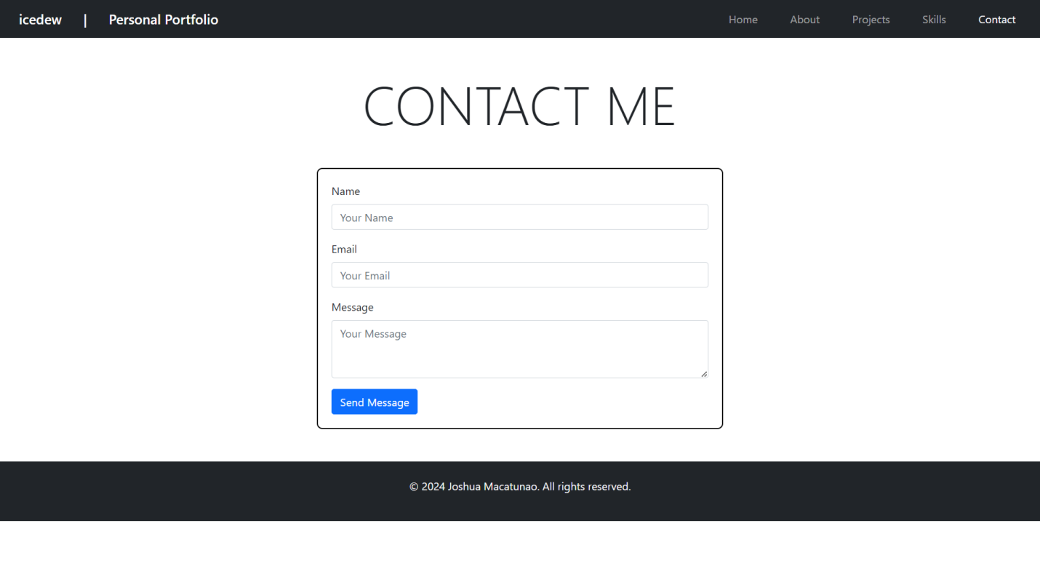

**SOURCE CODE**

**HTML**

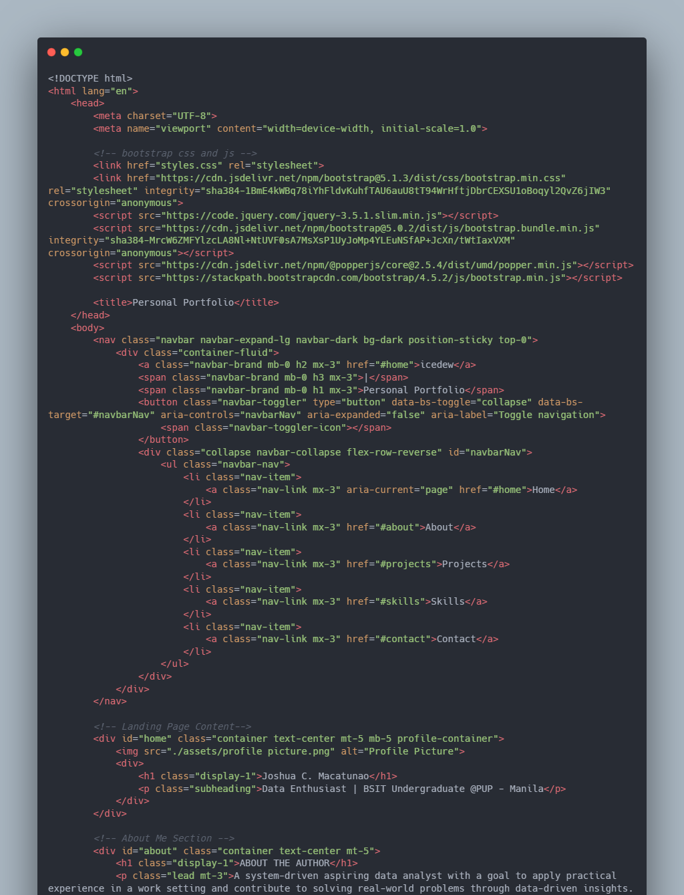

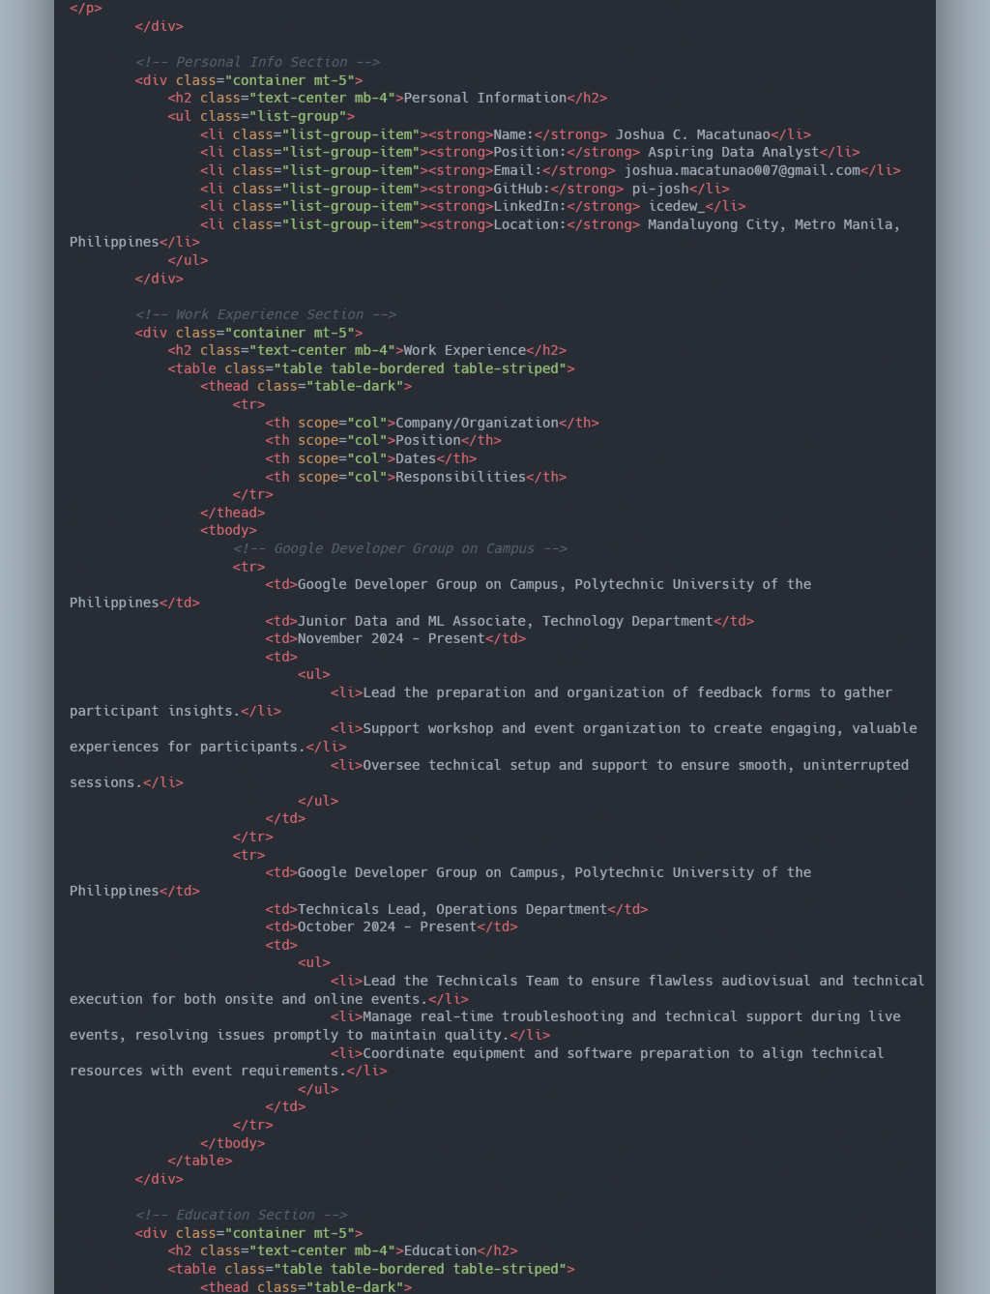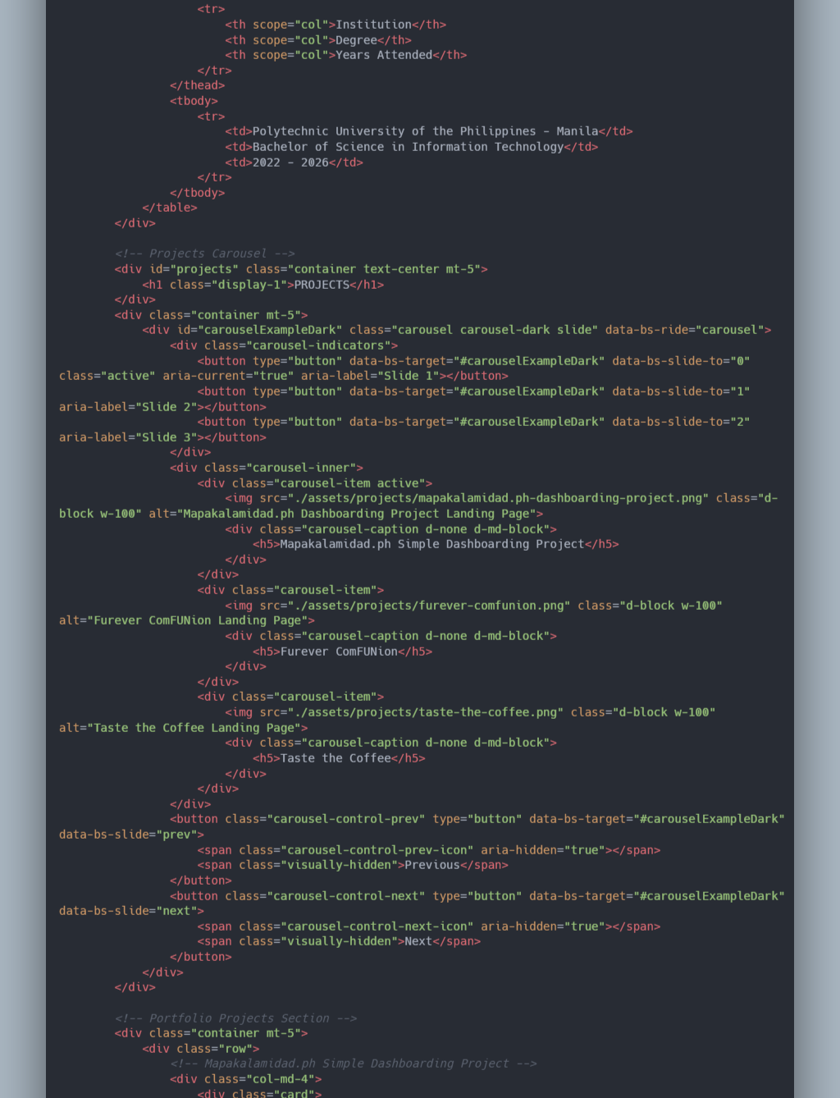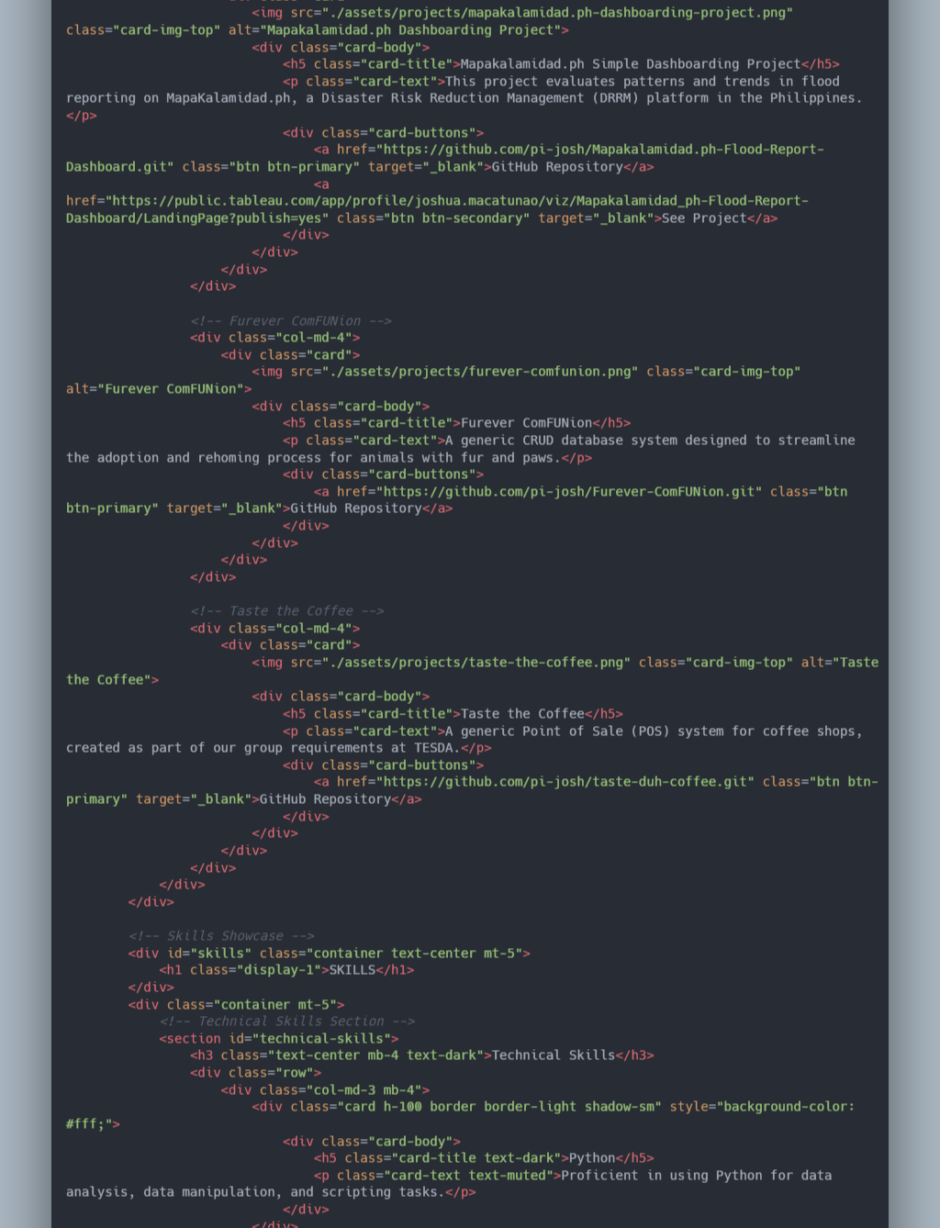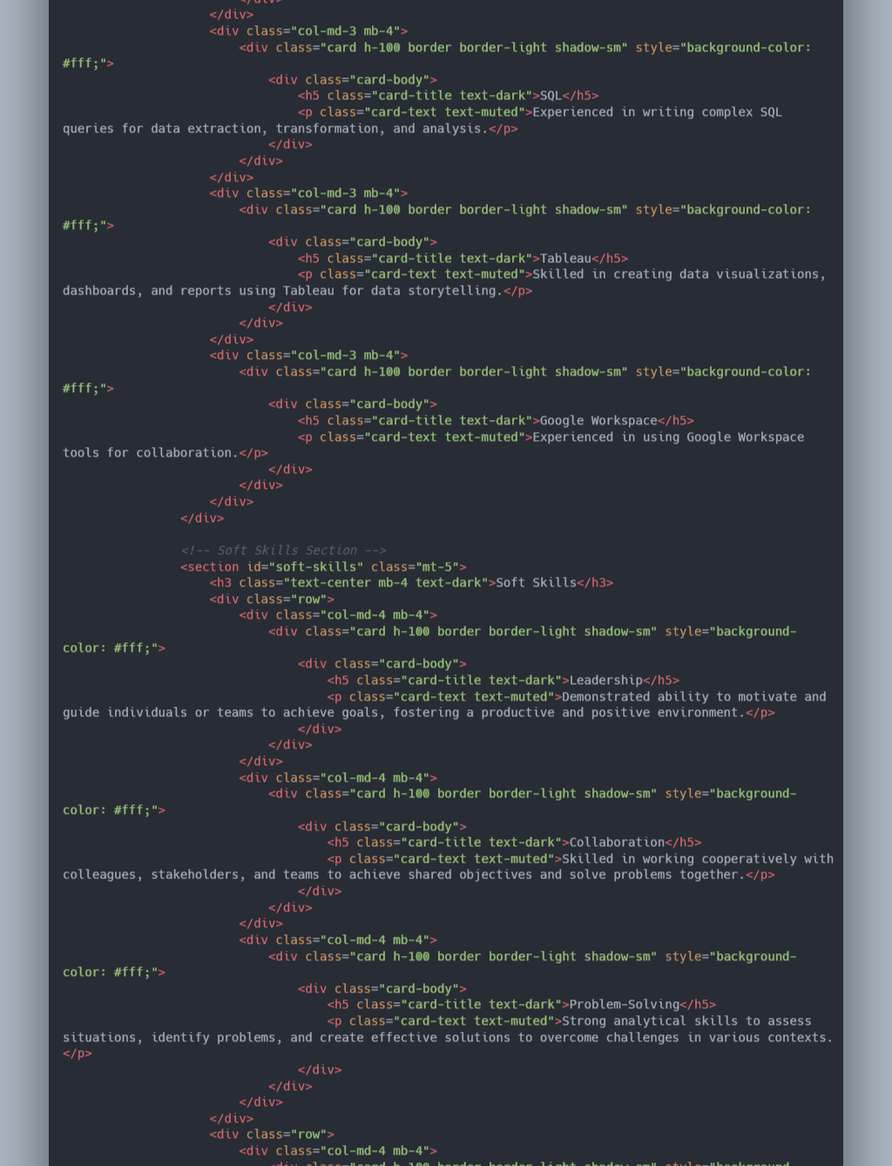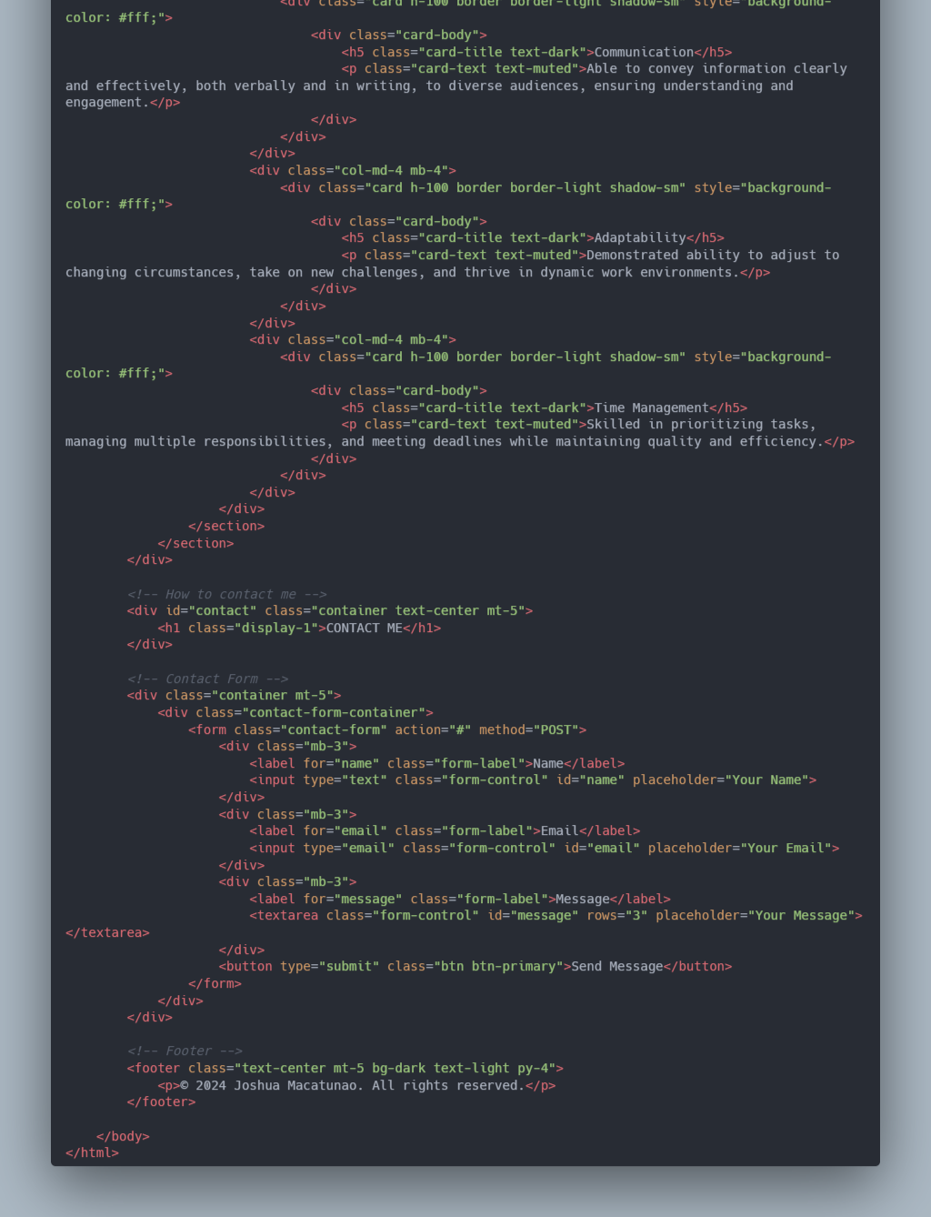

**CSS**

